A friend mentioned this topic, and once I started exploring it, the median comparison of the Fab Four turned out to be a rabbit hole — one I absolutely loved.” Batting averages are one of the most common ways to compare batsmen. But sometimes, as identified in the case of the Bannerman by Wilson in his article “Batting Medians”. Often times an outlier value can skew the average making a batsman look much better than he actually is. The sample size does make a difference; however, it highlights an issue with the batting average as it is predominantly used.
Looking at the batting average there is a general tendency to consider 50 as being great, and anything over 40 in Test cricket is good. The median score, however, highlights how often batsmen actually get to 50’s or even 40’s.
Anantha Narayanan’s Cricinfo article, “What median scores tell us about batting careers” highlights this, where even the great Bradman who averages 99.94 and has a mean of 87.45, only has a median score of 56.5 (and I say only compared to his average). Which is to say out of his 80 innings Bradman scored 56 runs or more half of the time, and the other half he scored less than 56. Those are still some imperious numbers compared to the rest as can be seen in the two articles mentioned above.
Our focus here is on the Fab Four, and although, Kohli has now retired from Test cricket it still makes sense to look at the original Fab Four.

Player | Batting average | Mean | Median | Mode (excluding zero)
V. Kohli | 46.85 | 43.95 | 23.0 | 1.0
J. Root | 51.29 | 47.02 | 29.0 | 6.0
S. Smith | 56.02 | 49.41 | 33.0 | 4.0
K. Williamson | 54.88 | 49.87 | 32.0 | 4.0

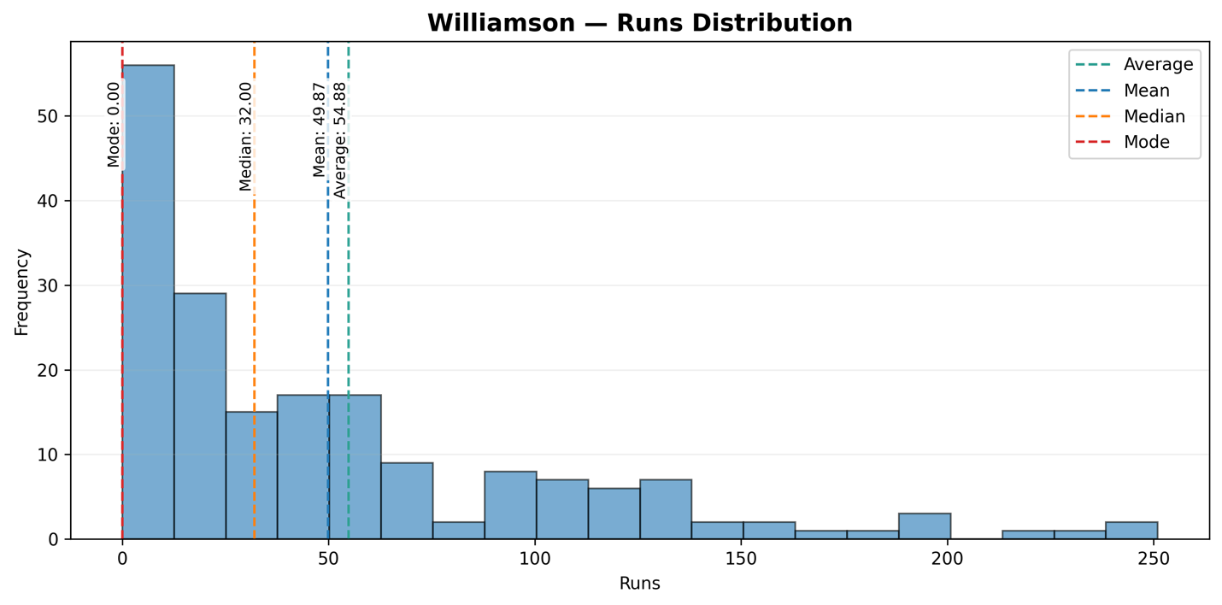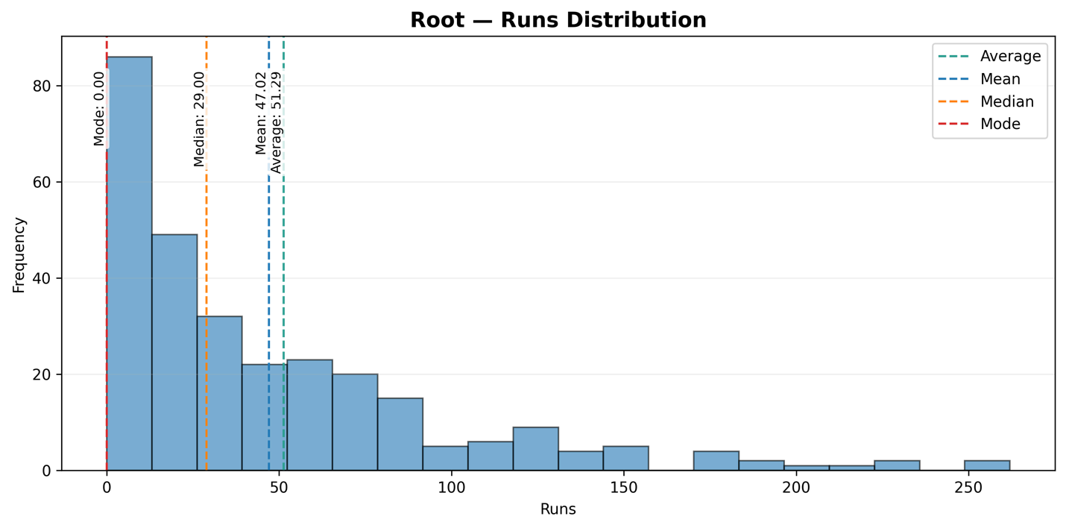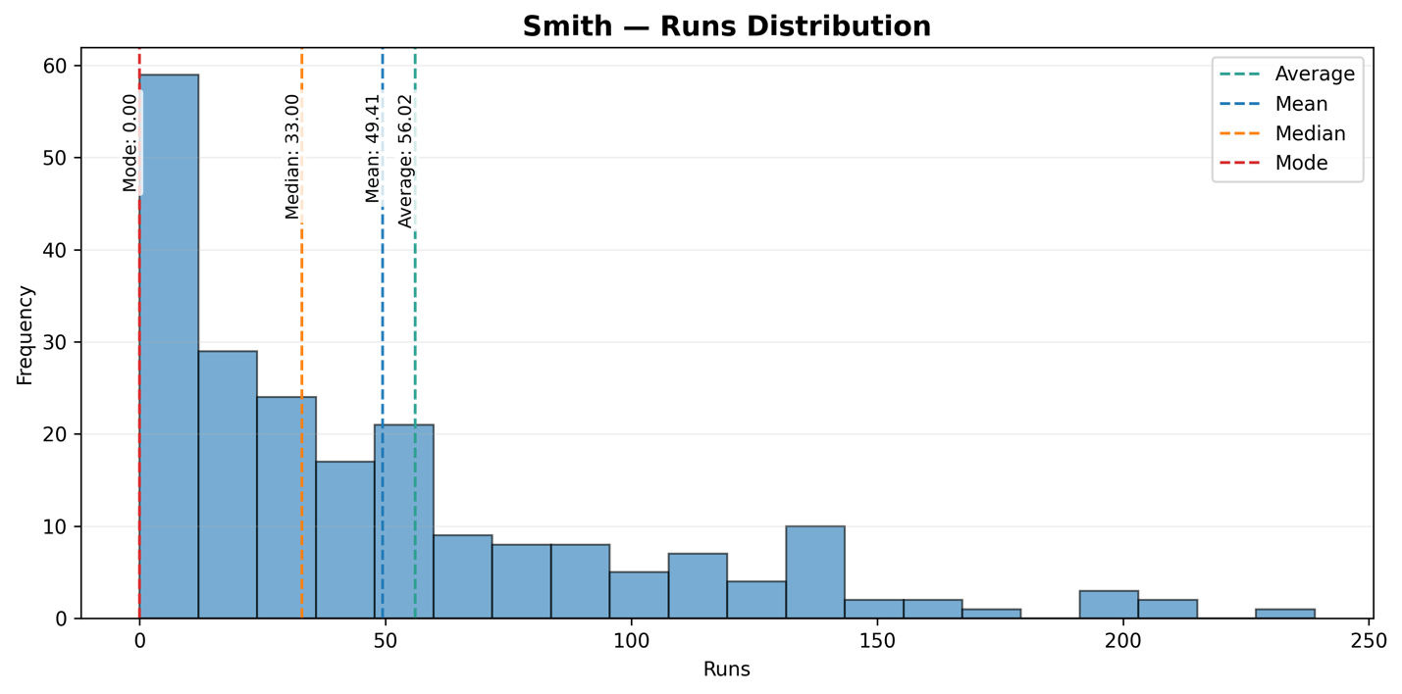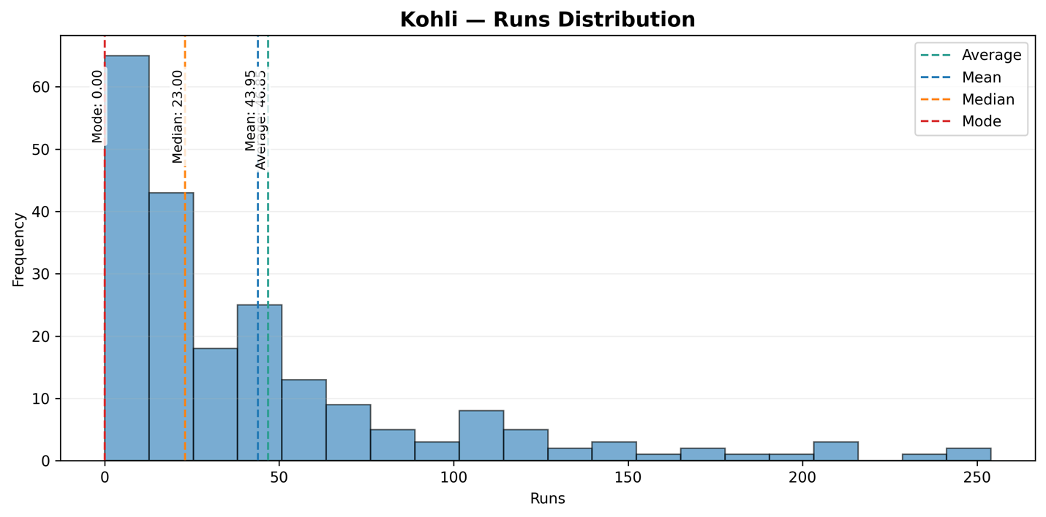
We can see, as with the great Don, that the Fab Four’s median scores fall well below their averages. Which is to say, even the Fab Four fail to reach their median scores in half their innings.
Burkard Polster and Marty Ross write in their piece- The median is the message “The median of mere mortal batsmen is typically in the low 30s.” In that regards the Fab Four are right up there with the mortals. But, then again, as Wilson writes in Batting Medians “Looking at all of the batsmen, it appears that a median of 30 is a measure of greatness.” – it looks as if the Fab Four have now become a Fab Three with Kohli languishing closer to the 20’s than 30’s and now having retired from test cricket altogether.

Looking at the mode (excluding the ducks) gave out some pretty interesting numbers as well. The mode is the value which is most represented in the data set, and in case of Root and Williamson, they both have been on 4 runs, with Smith having 6 runs as the mode. Kohli again falters behind with his mode as 1 run.
Kohli leads the duck charts and has 15 ducks in his career, compared to 11 each for Smith and Williamson, and 13 for Root.
Another interesting exploration was to see how often when the Fab Four get to their median scores go on to score big.

Player (median) | median to 49 | 50-99 | 100-149 | 150+
V. Kohli (23) | 47 (43.52%) | 31 (28.70%) | 19 (17.59%) | 11 (10.19%)
J. Root (29) | 43 (29.05%) | 66 (44.59%) | 23 (15.54%) | 16 (10.81%)
S. Smith (33) | 28 (26.17%) | 43 (40.19%) | 27 (25.23%) | 9 (8.41%)
K. Williamson (31) | 24 (25.53%) | 37 (39.36%) | 22 (23.40%) | 11 (11.70%)

The Fab Four, when they do get to their respective median scores, tend to push on and get bigger scores. Root goes on to get a hundred or more around 26% of the times, Kohli about 27 % of the times, Smith about 33% of the times, and Williamson a crazy 35% of the times. Kohli tends to be dismissed between his median score 23 and 49 most times, but for the rest, they get dismissed below 50 only about a quarter of times and usually push on to get somewhere between a 50 to 99, or over 100 about 75% of the times.
Finally, I wanted to explore a series of streaks to see how consistent the Fab Four have been in getting to their median scores.

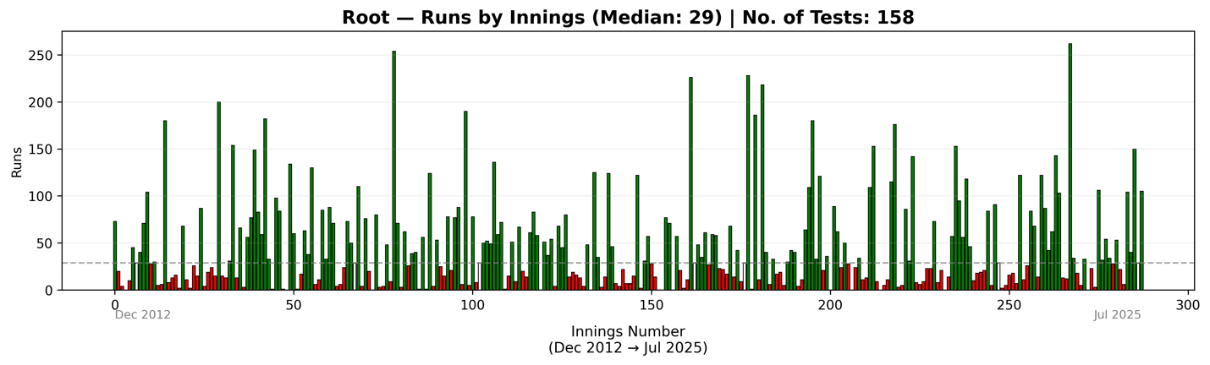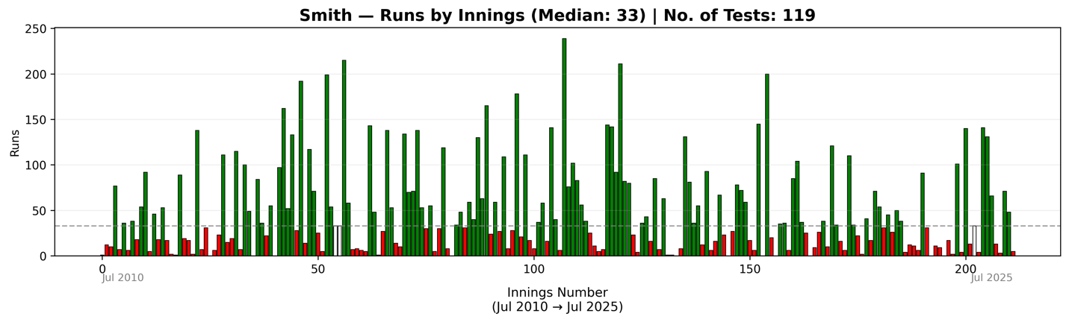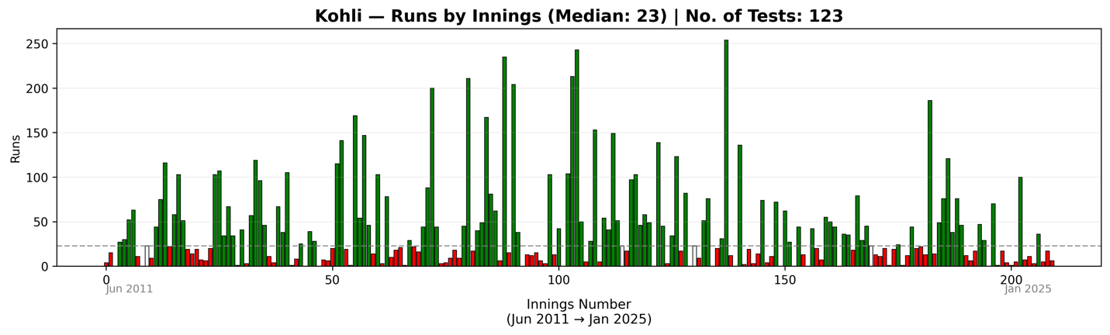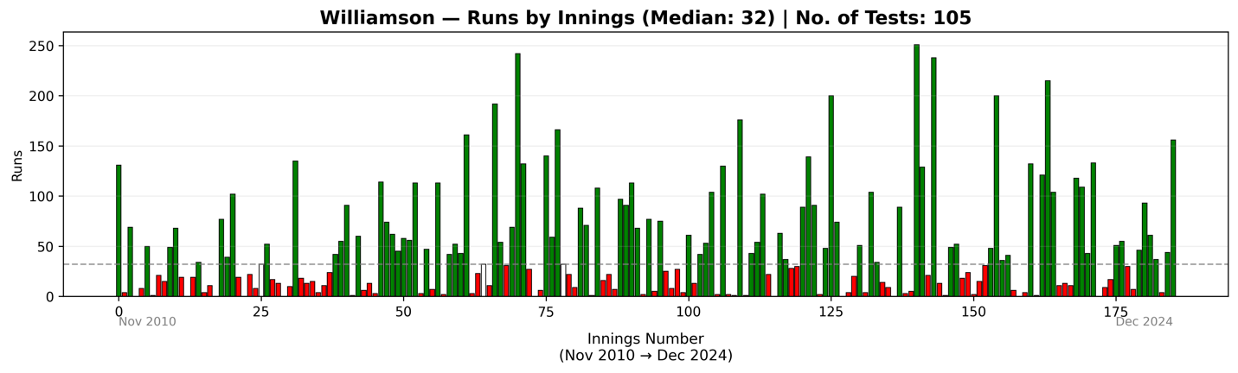
The red bars are the scores below median score, and the green ones are the runs above the median scores. It gives a great visual reference of how the Fab Four have scored, but also how often they’ve failed at scoring 30 runs or more.
Below is a table of the streaks of runs the batsmen has put at getting more than their median scores. The table only looks at streak of 4 or more than 4 innings. And going into the Ashes, Root and Smith both look like they have recent streaks, meaning they come both seem to be coming in back of some real form. Joe Root looks ominous; he comes in on the back of that great series against India and is in the middle of a streak of five. While Smith is also coming in hot but had that streak of 3 broken by South Africa, and then only to have his another streak of 2 broken in the third test against West Indies. Smith, Root, and Williamson, all seem to have enjoyed a streak of at least 7 stints of going past their median scores in the past.
Smith :
Start Date | End Date | Innings | Total Runs | Scores
2015-06-11 | 2015-07-16 | 6 | 592 | 54, 199, 33, 33, 215, 58
2015-12-26 | 2016-02-20 | 5 | 466 | 134, 70, 71, 138, 53
2016-11-24 | 2016-12-26 | 5 | 457 | 59, 40, 130, 63, 165
2017-12-02 | 2018-03-01 | 7 | 634 | 40, 239, 76, 102, 83, 56, 38
2019-08-01 | 2019-09-12 | 6 | 751 | 142, 144, 92, 211, 82, 80
2021-01-07 | 2021-01-15 | 4 | 303 | 131, 81, 36, 55
2022-12-17 | 2023-02-09 | 4 | 262 | 36, 85, 104, 37
2025-01-29 | 2025-06-11 | 3 | 338 | 141, 131, 66

Root
Start Date | End Date | Innings | Total Runs | Scores
2013-03-22 | 2013-05-24 | 5 | 289 | 45, 29, 71, 40, 104
2014-07-27 | 2015-05-01 | 7 | 639 | 56, 77, 149, 83, 59, 182, 33
2015-10-13 | 2015-10-22 | 4 | 277 | 85, 33, 88, 71
2015-12-26 | 2016-01-14 | 4 | 262 | 73, 50, 29, 110
2017-07-27 | 2017-08-25 | 7 | 447 | 29, 50, 49, 52, 136, 72, 59
2018-03-22 | 2018-05-24 | 4 | 210 | 51, 37, 54, 68
2019-11-29 | 2020-01-03 | 5 | 399 | 226, 29, 48, 35, 61
2021-08-04 | 2021-09-02 | 6 | 543 | 64, 109, 180, 33, 121, 36
2023-02-24 | 2023-06-16 | 5 | 468 | 153, 95, 56, 118, 46
2024-07-18 | 2024-08-29 | 6 | 559 | 122, 87, 42, 62, 143, 103
2024-12-06 | 2025-05-22 | 4 | 226 | 106, 32, 54, 34
2025-07-10 | 2025-07-31 | 5 | 428 | 104, 40, 150, 29, 105

Kohli:
Start Date | End Date | Innings | Total Runs | Scores
2011-06-28 | 2011-11-22 | 4 | 172 | 27, 30, 52, 63
2012-12-13 | 2013-03-14 | 5 | 345 | 103, 107, 34, 67, 34
2013-11-14 | 2013-12-26 | 4 | 318 | 57, 119, 96, 46
2014-12-26 | 2015-01-06 | 4 | 416 | 169, 54, 147, 46
2015-12-03 | 2016-07-30 | 4 | 376 | 44, 88, 200, 44
2016-11-09 | 2016-11-26 | 5 | 399 | 40, 49, 167, 81, 62
2017-11-16 | 2017-12-02 | 4 | 610 | 104, 213, 50, 243
2018-01-24 | 2018-08-09 | 5 | 318 | 54, 41, 149, 51, 23
2018-08-18 | 2018-09-07 | 5 | 353 | 103, 97, 46, 58, 49
2023-07-12 | 2024-01-03 | 5 | 357 | 76, 121, 38, 76, 46

Williamson
Start Date | End Date | Innings | Total Runs | Scores
2013-10-09 | 2014-02-06 | 7 | 522 | 114, 74, 62, 45, 58, 56, 113
2014-06-08 | 2014-06-26 | 5 | 411 | 113, 42, 52, 43, 161
2014-12-26 | 2015-05-21 | 4 | 497 | 54, 69, 242, 132
2015-11-05 | 2015-11-13 | 4 | 397 | 140, 59, 166, 32
2016-02-20 | 2016-08-06 | 4 | 369 | 97, 91, 113, 68
2018-12-03 | 2018-12-26 | 4 | 367 | 89, 139, 91, 48
2022-06-23 | 2023-01-02 | 4 | 325 | 48, 200, 36, 41
2024-02-04 | 2024-02-13 | 4 | 403 | 118, 109, 43, 133
2024-09-26 | 2024-12-06 | 4 | 237 | 46, 93, 61, 37

